The Menu Solver, explained:

A series of equal width cells for a menu in a web page, placed horizontally side-by-side often cannot be sized with integers, the requirement for web page code. Task: design a formula to determine the width of the odd cell. The argument: Reduce the quotient of finding equal widths to an integer, use the integer for the widths of n – 1 cells, n = the number of cells. Subtract n – 1 spacer widths, subtract the sum from the total width of the menu.

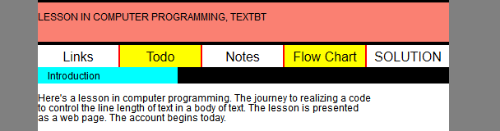

Variables:
t = total width
y = equal cells width
x = odd cell width
n = number of cells
s = spacer width

Step one, equal cells:

y = (t – (n – 1)*s)/n

Step two, odd cell:

x = t – (int(y)*(n – 1)) – (n – 1)s

Note: “int” is taking the integer part of a rational(fractional) number.

Bill Tonnesen………………………..25.March.2016

